Marathwada Mitra Mandal's
COLLEGE OF ENGINEERING
Karve Nagar, Pune-411052
Accredited with 'A' Grade by NAAC

DEPARTMENT OF COMPUTER ENGINEERING

BE PROJECT SYNOPSIS

Group ID: 1B1

1) Title of the project: NLP - Speech 2 Code

2) Domain of the Project: Artificial Intelligence

3) Keywords (ACM keywords):
Speech Recognition, Stack Automaton, Assistive Technology, User Interface Automation, Speech-to-Code Conversion.

4) Problem Definition: Creation of an assistive technology tool capable of assisting programmers
to program in JavaScript using their voice.

5) Abstract:
Repetitive strain injury (RSI) is a syndrome that affects thousands of professionals around the world every year, among these professionals are programmers, professionals who tend to make extensive use of their hands in carrying out their tasks and that is why more susceptible to RSI. Programmers affected by this syndrome have great difficulty in using their hands and consequently great difficulty in carrying out their main activity: programming, a historically text-based activity that requires extensive use of the hands.
That said, we come to the central theme of this work: the creation of an assistive technology tool capable of helping programmers to program in the JavaScript language using their voice. The tool
aims to enable programmers to program without using their hands, using only voice commands. parse sentences belonging to a given grammar using stack automata, how to connect and control code editors using UI automation tools, the process of creating a code editor extension Visual Studio Code and the creation of a cross-platform application using ReactJS and the Electron framework.

6) Scope of the Project:
Create an application capable of helping programmers to program in JavaScript without using their hands. This application will be able to listen and analyse voice commands and then manipulate any code editor in order to execute this command.

7) System Architecture (Functional Diagram):

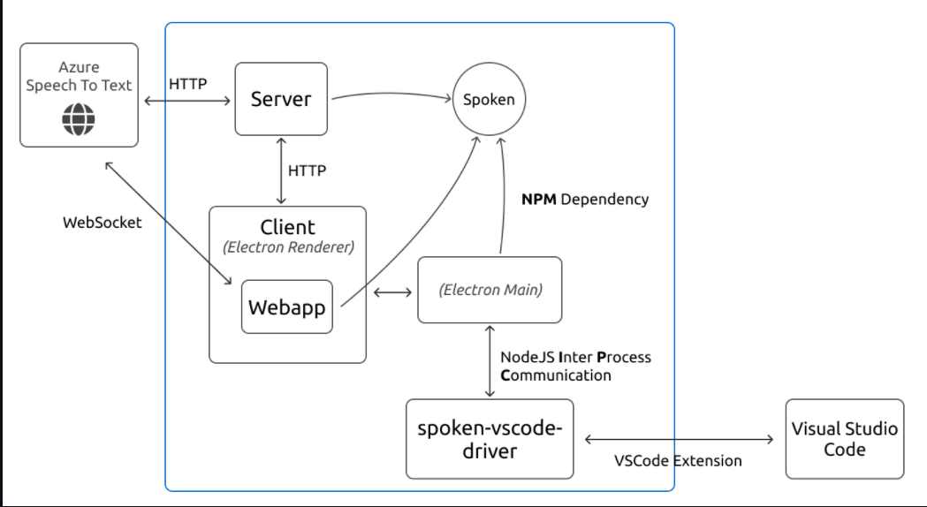

8) Software & Hardware Requirements:
The minimum requirements for the application to work fully are as follows:

- Network:
Stable and fast internet connection

- Operating System:
Tested on Windows 10 only

- Memory:
At least 3GB of ram and 270MB of available disk space

- Python:
Tested with Python version 3.9.1

- Visual Studio Code:
Tested with version 1.55.2 of VS Code

9) Expected Outcomes:
Using this application instead of using your hands to write in the code editor, for example, the instructions needed to declare a variable, the programmer can simply express aloud that he wants to declare a variable which then the application will automatically connect to the code editor with the intention of writing the necessary instructions to declare a variable in the JavaScript language.

For this, the application must be able to: capture voice commands through from the computer's microphone, transform the voice command into text, validate the command and, finally, connect to the code editor in order to execute the command.

10) Team Members:
Roll No. | Name of Student | Mobile Number | Sign
BC170 | Bhavika Mauli Karale | 8275545511
BC171 | Sameeksha Avinash Joshi | 8805267461
BC173 | Siddharaj Gangavane | 9730906215
BC174 | Rutuja Shewale | 8668691756

11) Guide/Mentor Details:
Guide/Mentor | Name | Organization | Email-ID | Mobile No.
Internal Guide | Prof. Arati Agarkar | MMCOE
External Guide(in case of Sponsorship)

12) References:

- Repetitive Strain Injury (RSI) among computer users: A case study in telecommunication company
Nurul Huda Baba, Dian Darina Indah Daruis

- Deep Variational Filter Learning Models for Speech Recognition
Purvi Agrawal, Sriram Ganapathy

- Unifying Speech Recognition and Generation with Machine Speech Chain
Andros Tjandra,, Sakriani Sakti, Satoshi Nakamura

- A Study on Automatic Speech Recognition
Sahila Benkerzaz,Youssef Elmir, Abdeslem Dennai

Project Guide name & Sign

